`

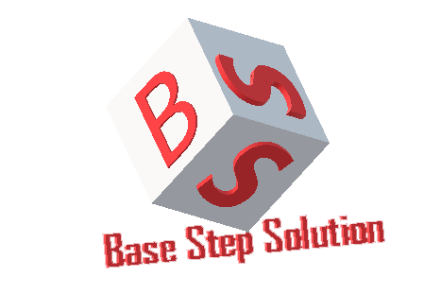

Meeting Minutes

Van Lang Admissions

# Revision Table

|  |  |  |  |
| --- | --- | --- | --- |
| Author | Date | Reason for changes | Version |
| Khoi Nguyen | 10/10/2017 | Initial Document | 1.0 |

Table of Contents

Revision Table 1

I. Purpose 3

II. Participant in meeting 3

III. Content of meeting 3

IV. To do task 4

|  |  |  |  |  |  |
| --- | --- | --- | --- | --- | --- |
| **Writer:** | Khởi Nguyễn | **Location:** | Room 706A | | |
| **Date:** | 10/10/2017 | **Start:** | 10h45 | **Finish:** | 12h15 |

# Purpose

* Discuss about Capstone Project
* Discuss about Team SWOT , Technology SWOT , Individual SWOT

# participant in meeting

Mentor Lê Sĩ Phú

Team Capston:

* Nguyễn Thái Hiền
* Nguyễn Hoàng Anh Tài
* Đoàn Anh Minh
* Trần Xuân Hải
* Nguyễn Xuân Thái Hiền
* Nguyễn Anh Khởi

# Content of meeting

- Introduce Team.

- Introduce Team Objective.

- Introduce Team Rule.

- Mentor introduce the purpose of Capstone Project

- Mentor suggest that who absence 3 times will be quit the Capstone project

- Mentor instructions on how to work.

- Mentor suggestions on how to write document.

- Mentor instructions on how to work breakdown.

- Mentor instructions on how to choose the process : recommended : Incremental process

- Agreement on the weekly meeting schedule : Every Monday. Send all meeting’s documents every Thursday.

- Agreement on the document was written in English.

- Discuss about System context.

- Ask about software development ( Use What ? How to use? How to connect SQL ? Use what to repository … ) : Recommended :

Nodejs : Research , learn in 1-2 weeks

Meteor : Research in Internet

- Discuss about Team SWOT , Technology SWOT , Individual SWOT : SWOT will not evaluate the objective reasons

# To do task

* Write Master Plan
* Topic Decision

---- *** ----